**Time and day of regular meeting slot :**

Thursday - Sunday 4pm we check in for new ideas or share new resources

**Summary of to-dos before next meeting:**

* Figure out next step for our data vis ( for now we have the main page as a map of the world which when you hover, you can see the names of the country and also the amount of migrations that's involved )
* Start working on the website showing data visualisation. Add CSS and JavaScript for, and also D3 for the charts.

**Screenshots of you logged into:**

**GitHub repository**

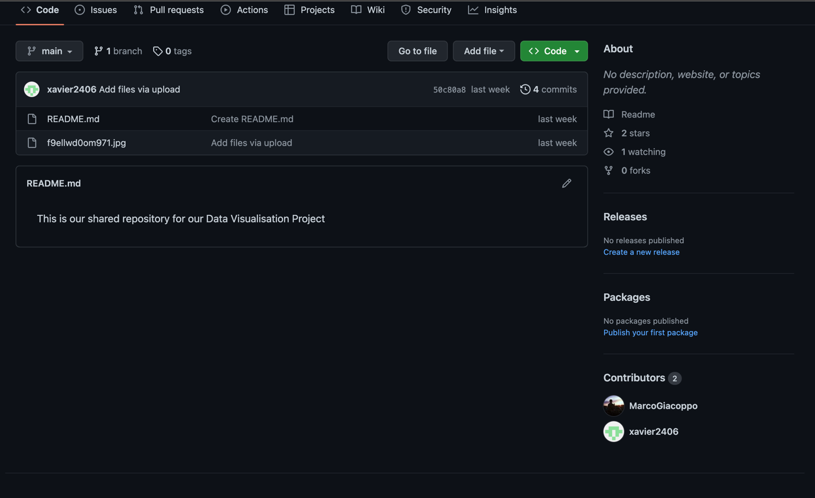

**Shared drive/documentation**

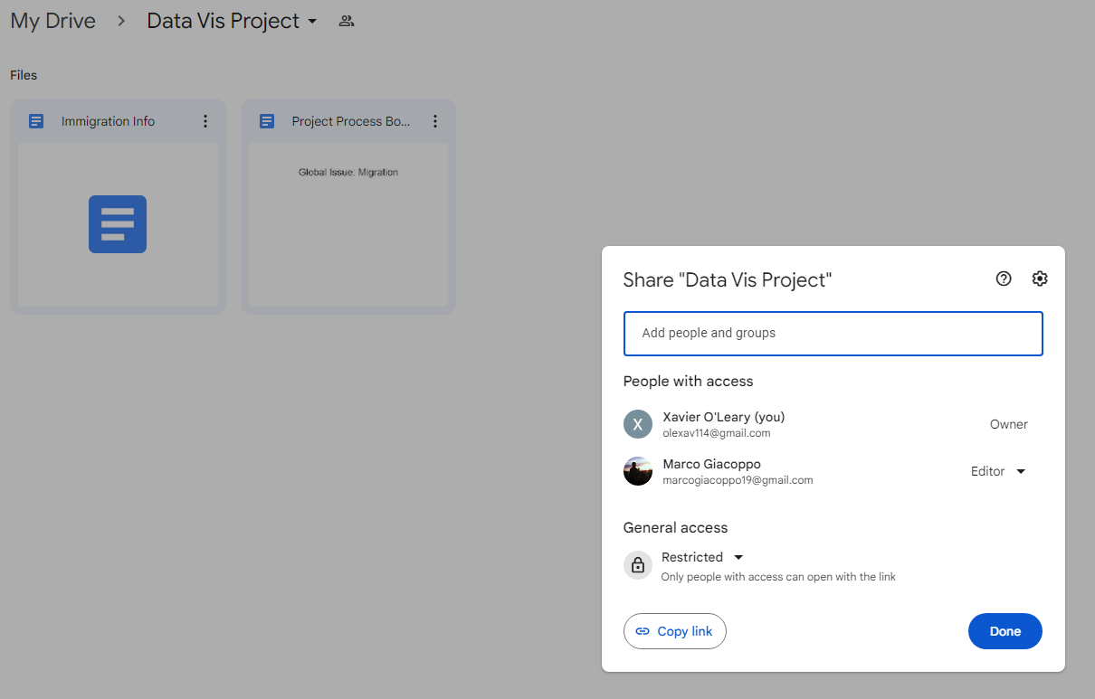

**Communication Channel**

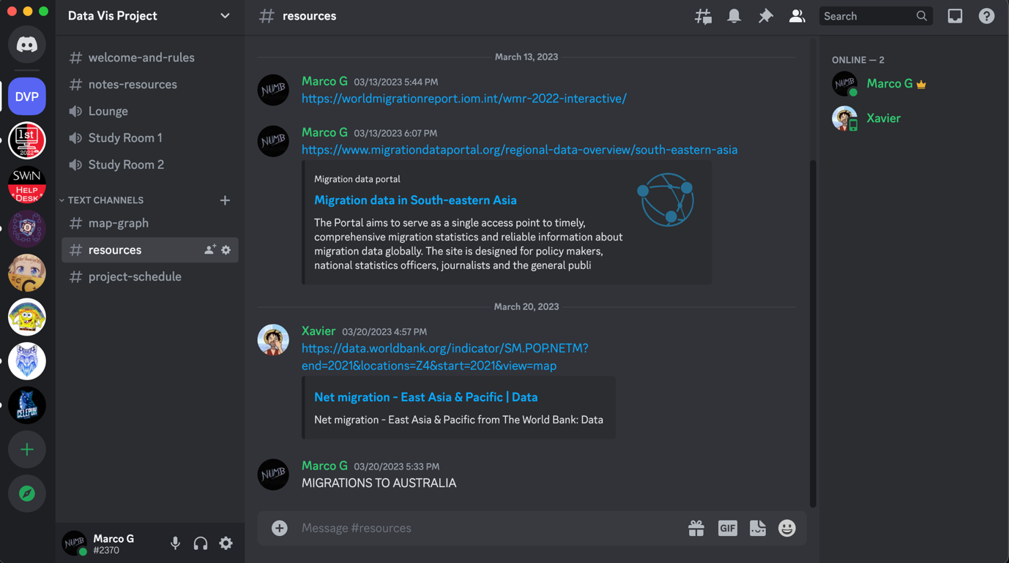

**Project schedule (estimate of what you will be doing when):**

* Week 1-2: Start working on the project, gather information regarding the topic and start deciding which one to use and which visualisation are we using
* Week 3-4: Start Preparing on how the website would look like
* Prepare some images on how we want it to look like
* Start on designing the home page or give a presentation how it would look like
* Figure out which chart are we going to use
* Week 5-7: Focusing on determining which data are we using and start coding the website
* Gather as much information as we can and start implementing them towards our charts using D3
* Week 8: Finish the website
  + Fix the websites and add more CSS or JavaScript to make it nice
  + Figure out what to do if there’s an error or something is not working properly ( finishing touches )
* Week 9: Finish the Data Visualisation Process Book
  + Complete the Process book
* Week 10-12: Finalize the project
  + Check with tutor if everything is working properly
  + Submit everything